

**CS7079 Data Warehousing and Big Data - Autumn 2022-23. PART B.**

21025221



January 12, 2023

samrat rai

21025221

**2. Create a Relational Database to store dimensions and fact tables using Microsoft SQL Server Management Studio.**

2.1 create a database:

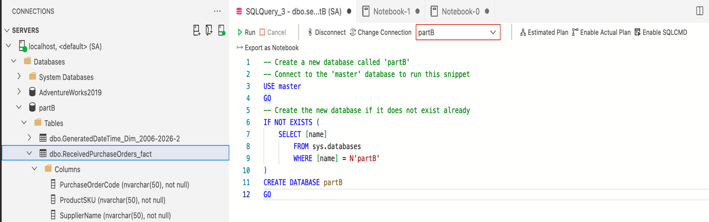

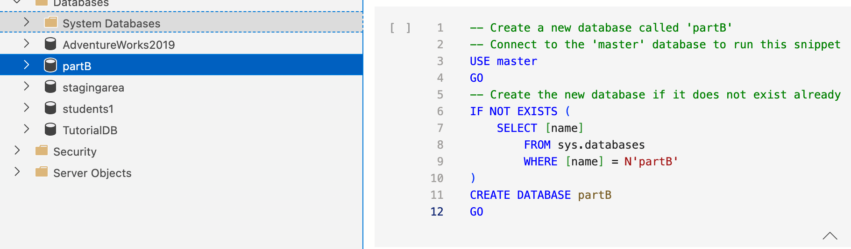

Created a database called ‘partB’ in azure data studio as SSMS is not available in MAC laptop. As you can see in the right-hand side of the picture above is where I used MsSql to create database and left-hand side where the database ‘partB’.

2.2 create dimensional tables:

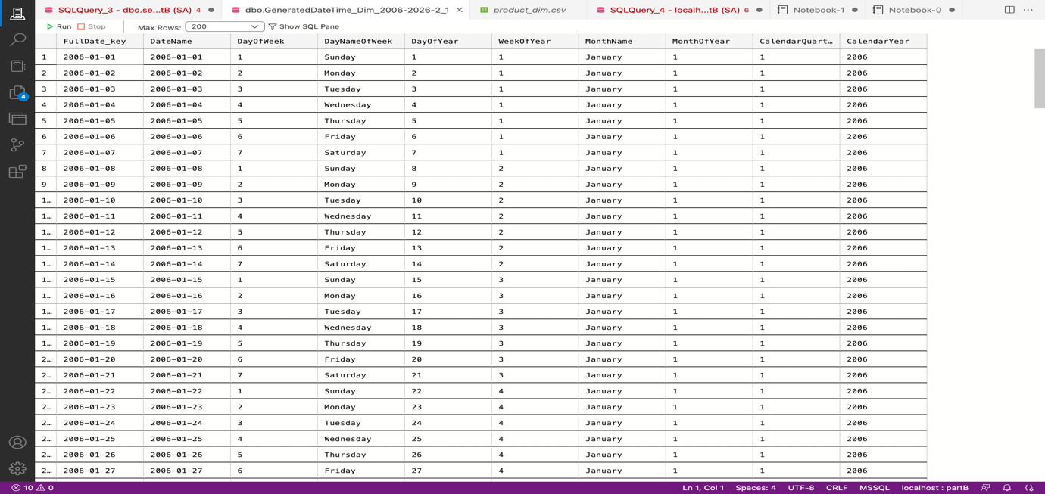

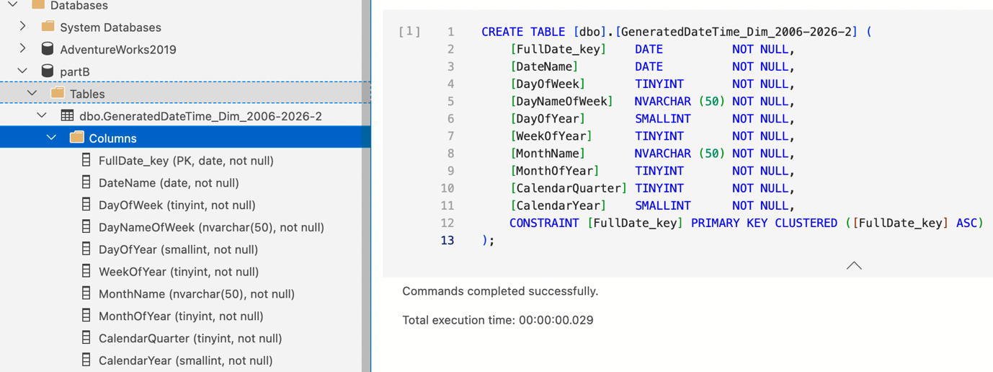

Fig 1. date dimension. here I created a date dimension table through azure data studio, where the first figure is the dimensional table and the second figure is the code and where the dimension is saved which named dbo.generateddatetime_dim_2006-2026-2 under the tables folder.

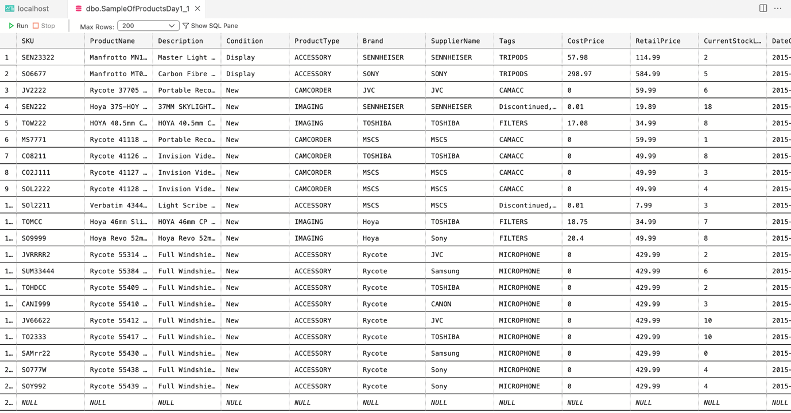

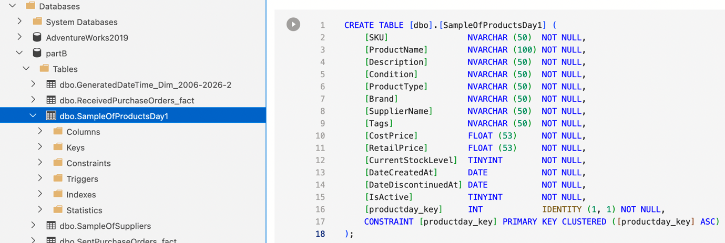

Fig 2. Product dim. here I created a product dimension table through azure data studio, where the first figure is the dimensional table, and the second figure is the code and where the dimension is saved which named dboSampleOfProductDay1, under the tables folder.

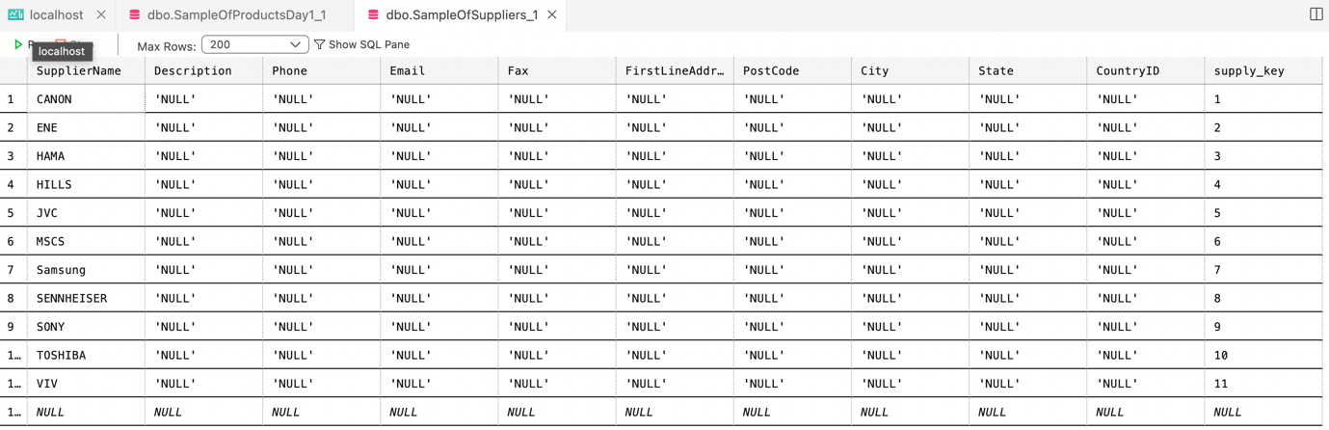

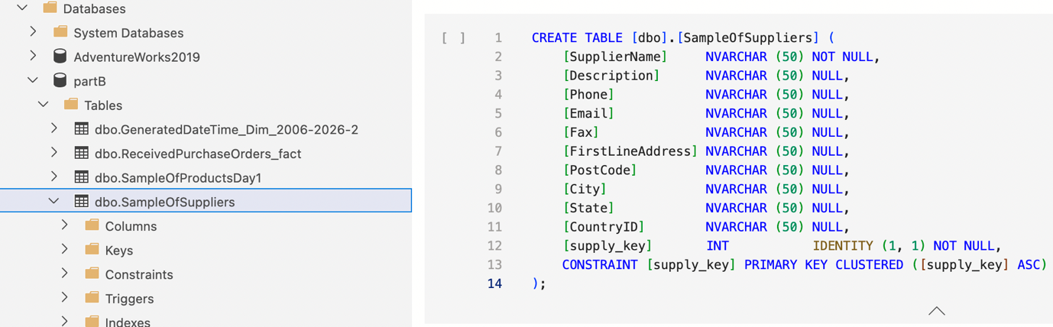

Fig 3. Supplier dim. here I created a supplier dimension table through azure data studio, where the first figure is the dimensional table, and the second figure is the code and where the dimension is saved which named dboSampleOfSuppliers, under the tables folder.

**2.3** Create fact tables.

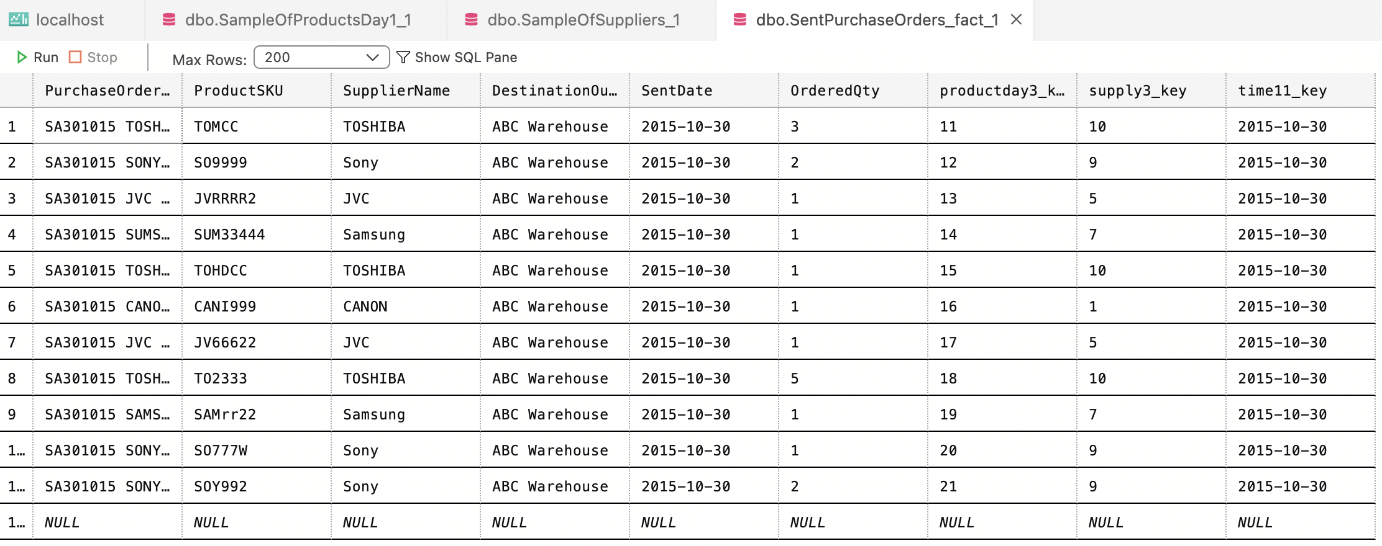

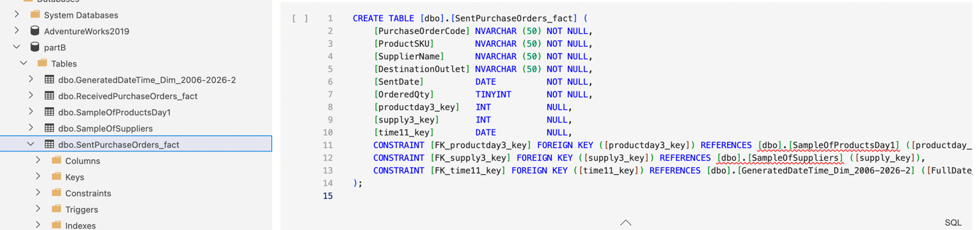Fig1.3 sent dim. here I created a SentPurchaseOrders fact table through azure data studio, where the first figure is the fact table, and the second figure is the code and where the fact table is saved which named dboSentPurchaseOrders_fact, under the tables folder.

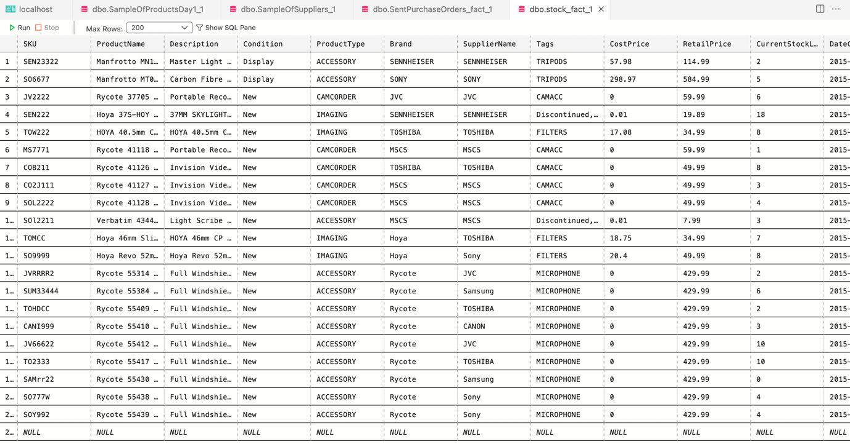

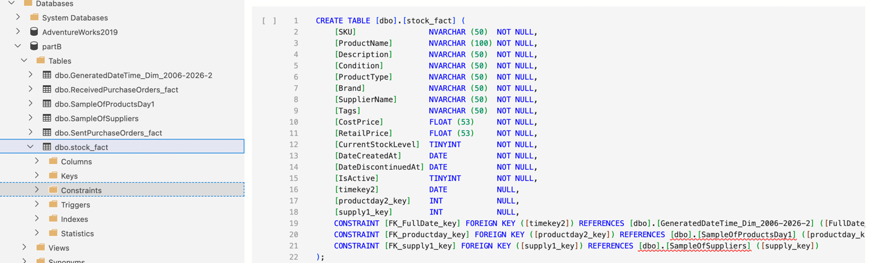

Fig 1.4 stock fact. here I created a stock fact table through azure data studio, where the first figure is the fact table, and the second figure is the code and where the fact table is saved which named dboStock_fact, under the tables folder.

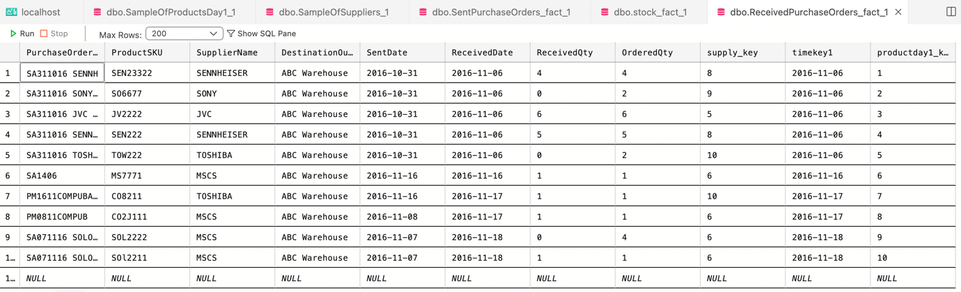

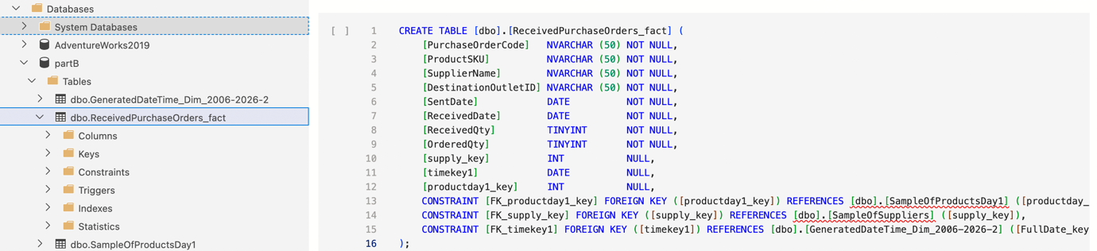Fig 1.5 receivedpurchaseorder fact. here I created a receivedpurchaseorder fact table through azure data studio, where the first figure is the fact table, and the second figure is the code and where the fact table is saved which named dboReceivedPurchaseOrders_fact, under the tables folder.

**2.4** Add appropriate primary keys and foreign keys constraints.

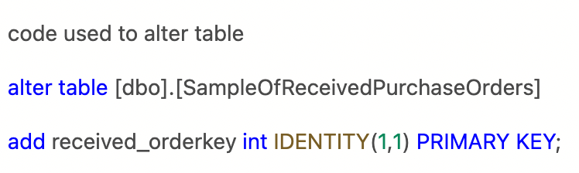

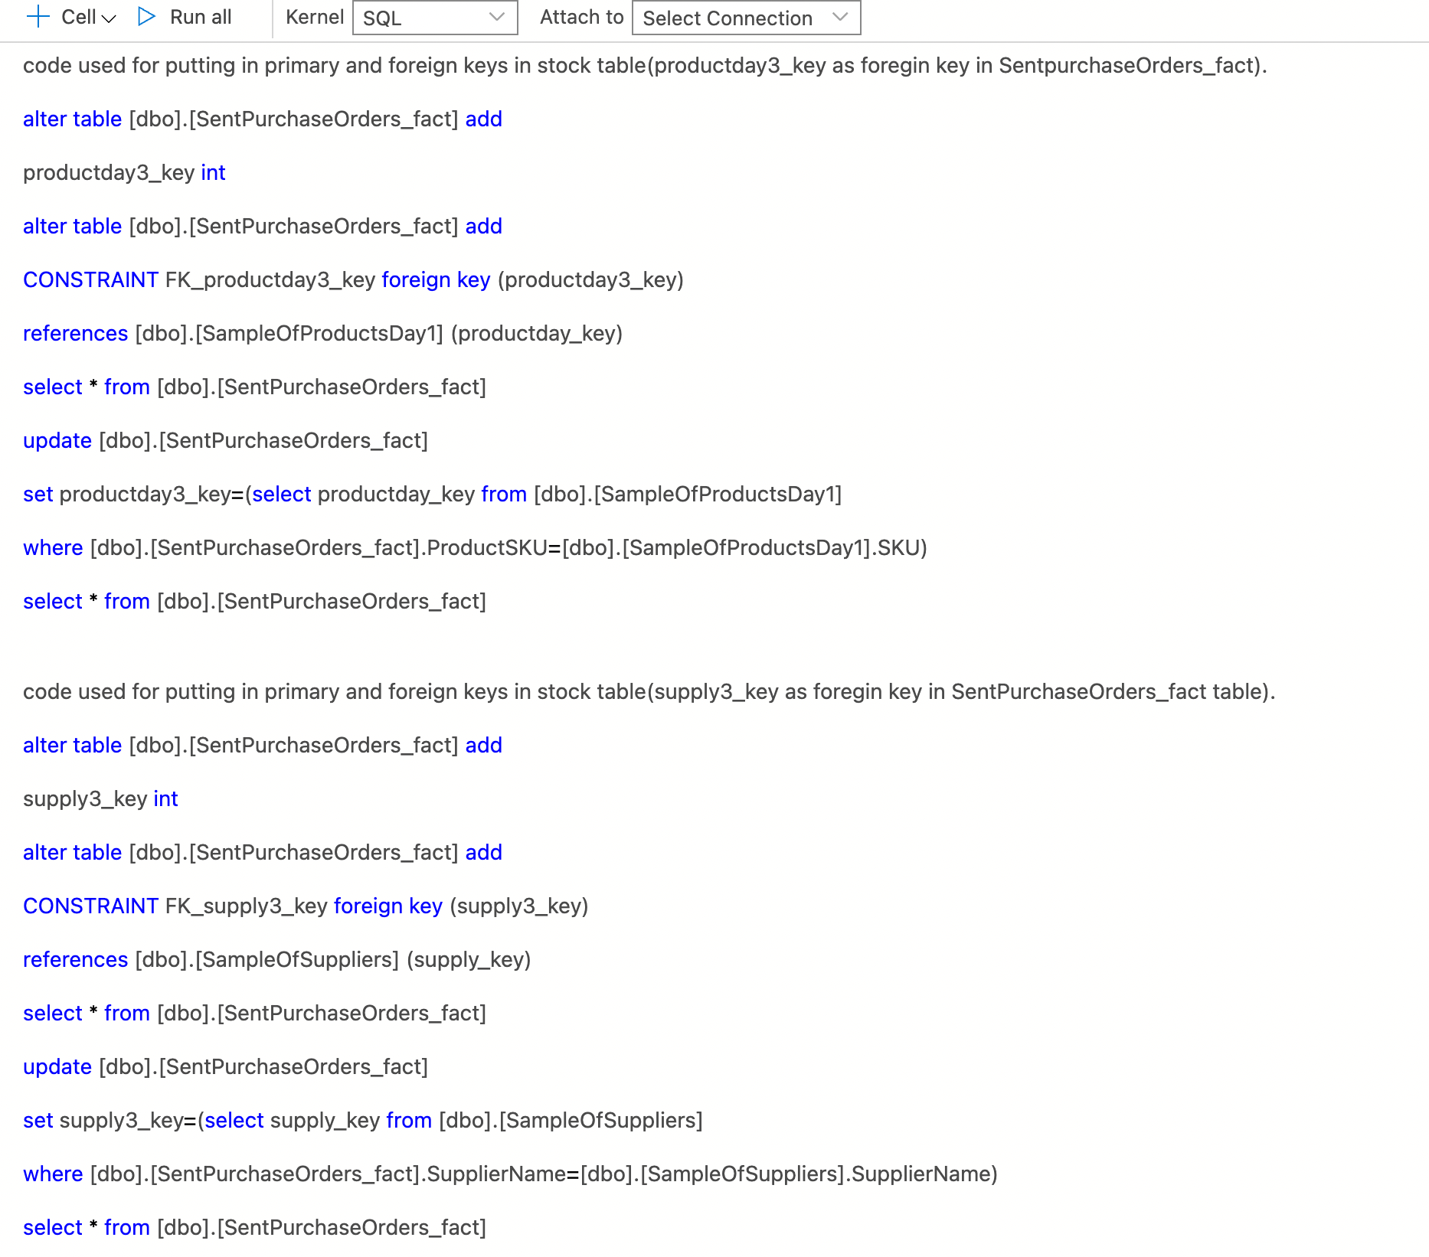

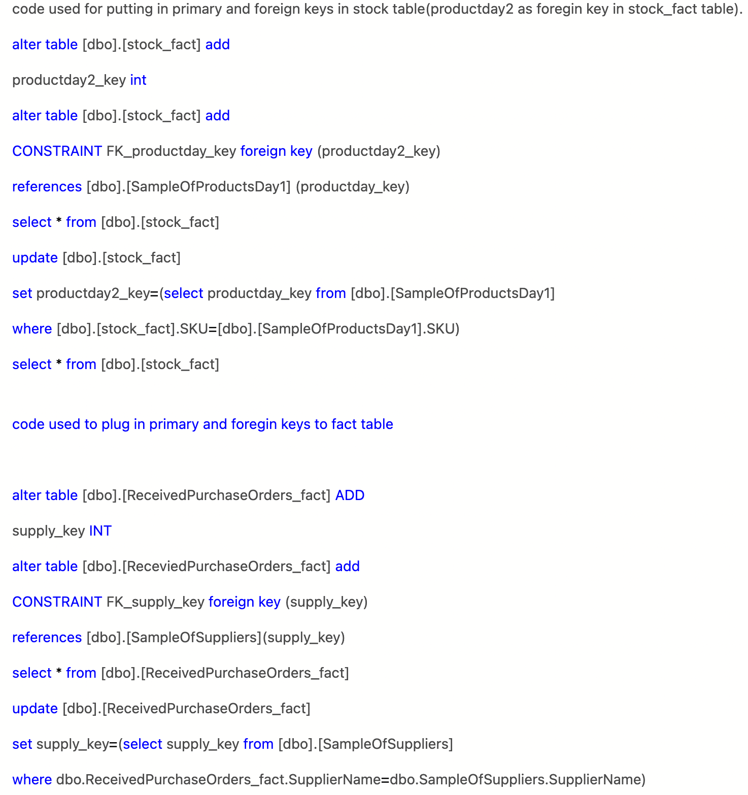

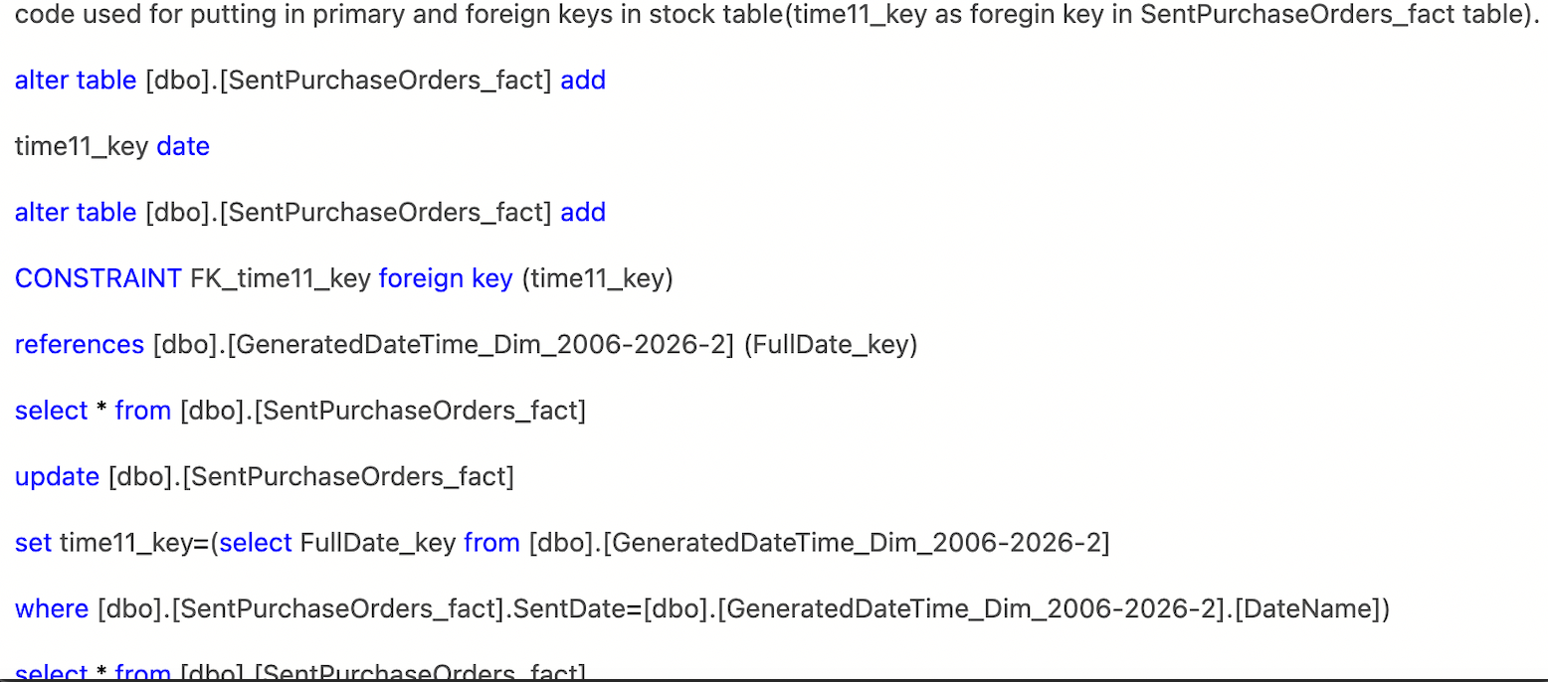

The above figures show the codes I have used to add primary keys and foreign keys constraint.

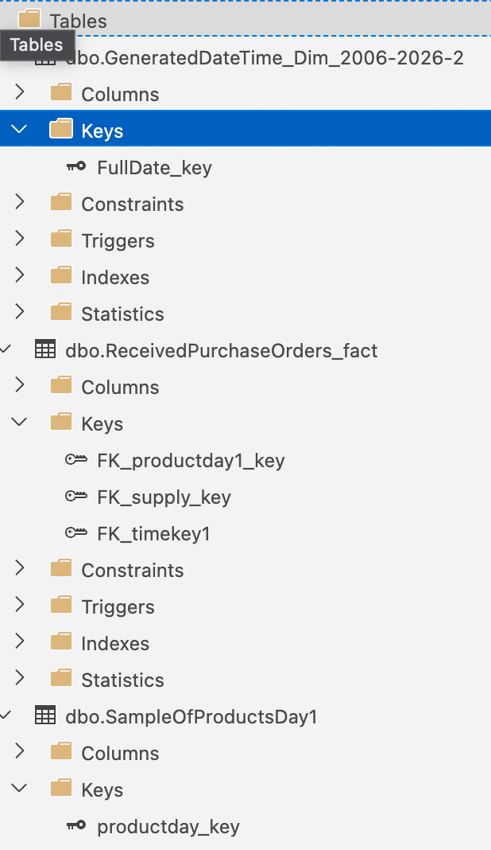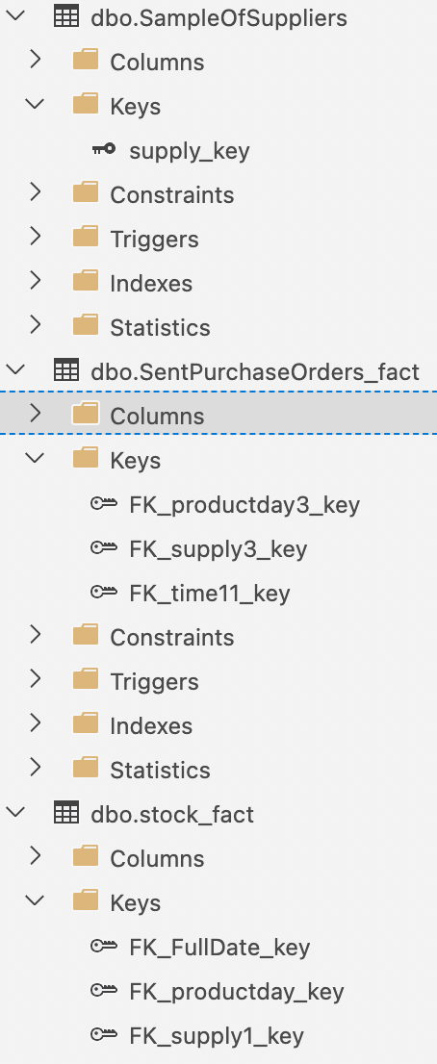

In the above figure, I have created one primary key for each dimensional table for example sampleofsuppliers has a primary key called supply key and stock fact table has 3 foreign keys called full date key, supply3 key and time11 key. I have done this for all dimensional tables and fact tables as you can see in the above figure.

**3. Migrate test data from the data warehouse to an Apache Hadoop platform for further analysis of Big Data using Hortonworks Data Platform (HDP)**

**3.1** Populate the data warehouse database with some test data.

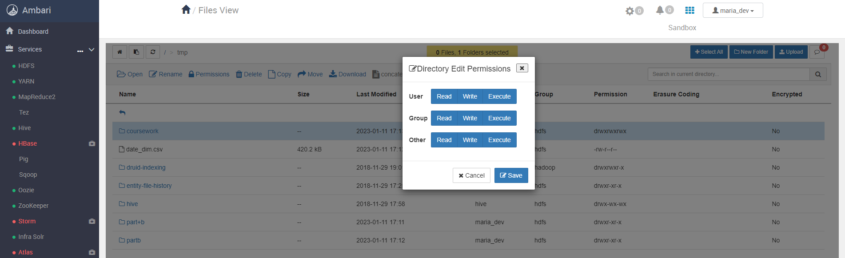

Here I am populating warehouse with some data used in azure data studio and editing Ambari’s data warehouse to enable me to read, write and execute code.

**3.2** Export the data warehouse database data into an external data file.

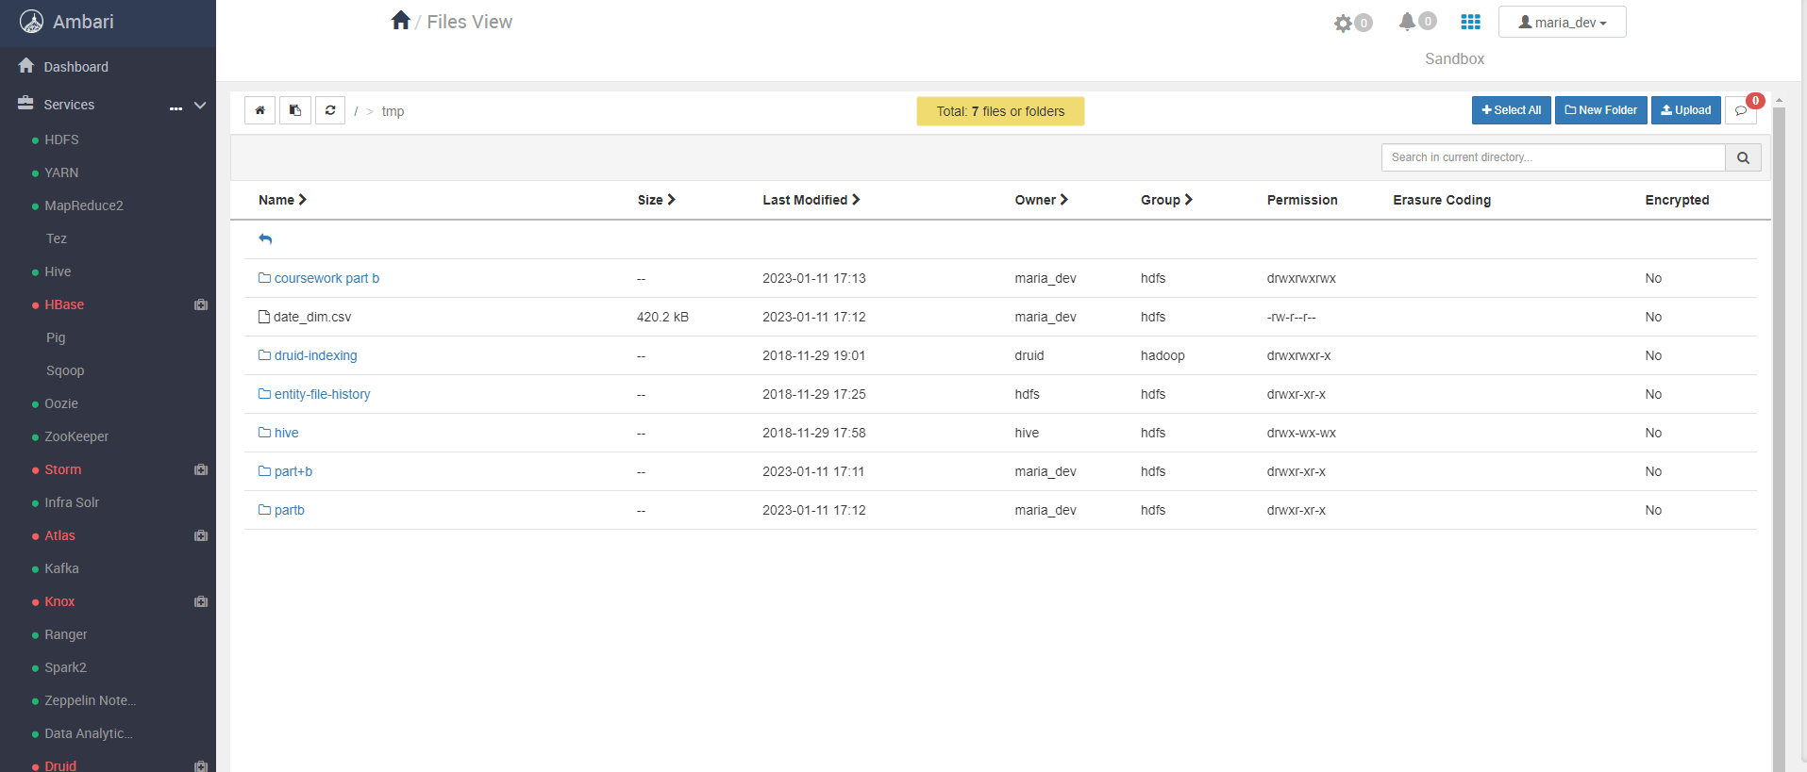

Here I have exported my database data that I used in azure data studio into an external data file called coursework part b in Ambari/Apache HDFS.

**3.3** Migrate the data file from the file system to Apache HDFS.

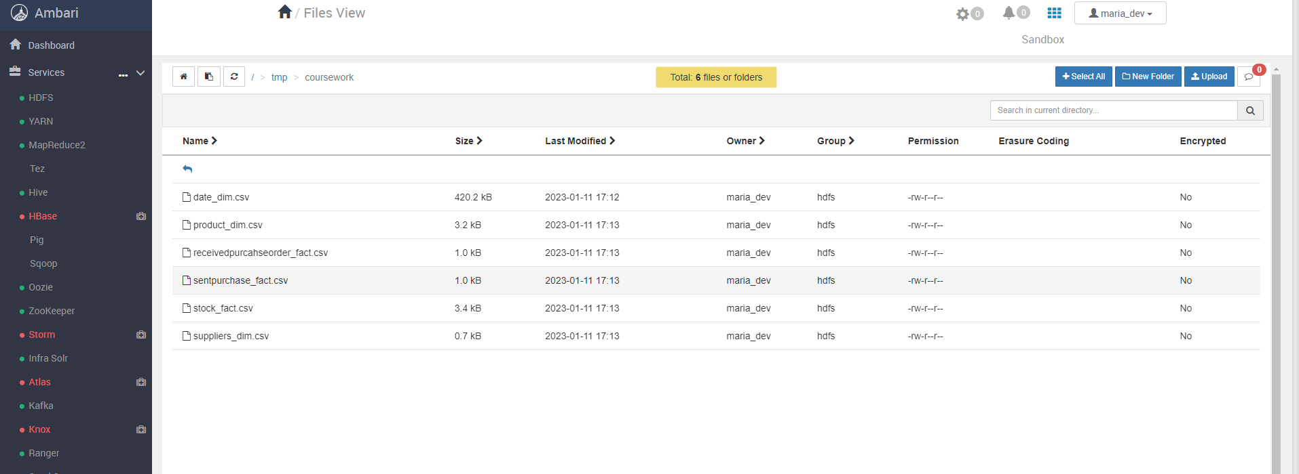

Here I have migrated all the csv files in Ambari/Apache HDFS which were used to create dimensions and fact tables in azure data studio

**3.4** Create a suitable data structure for loading the data file into HIVE

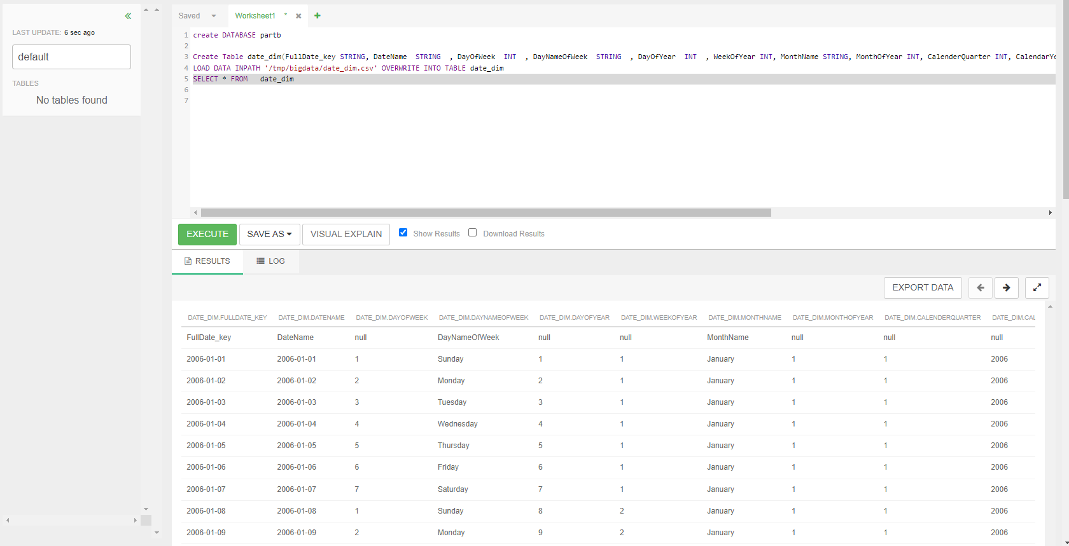

The above figure shows the code used to create date dimensional table. here I used Ambari dashboard and loaded the data file which was used in azure data studio into hive to recreate dimensional table model. MsSql was used to create dimension and table.

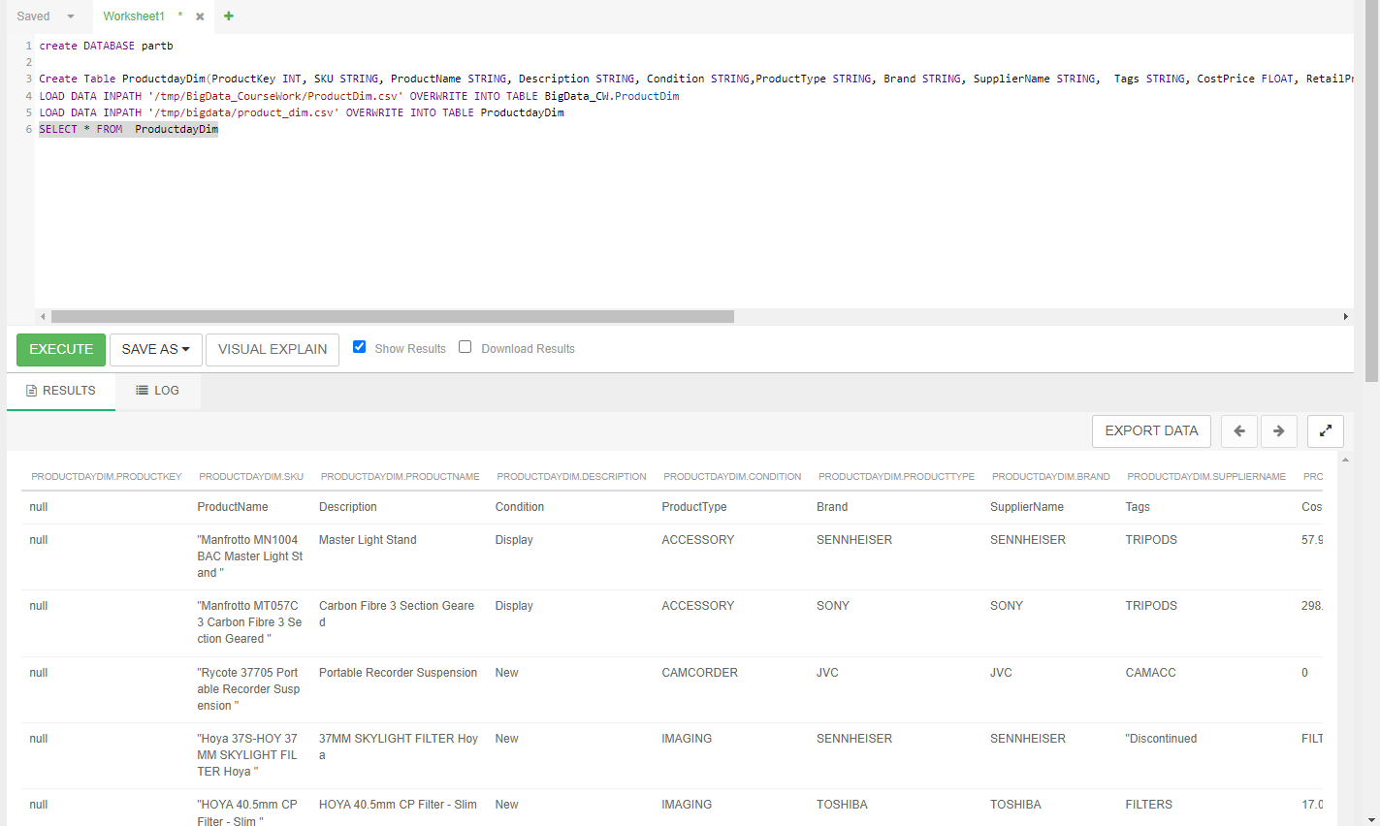

The above figure shows the code used to create product dimensional table. here I used Ambari dashboard and loaded the data file which was used in azure data studio into hive to recreate dimensional table model. MsSql was used to create dimension and table in hive.

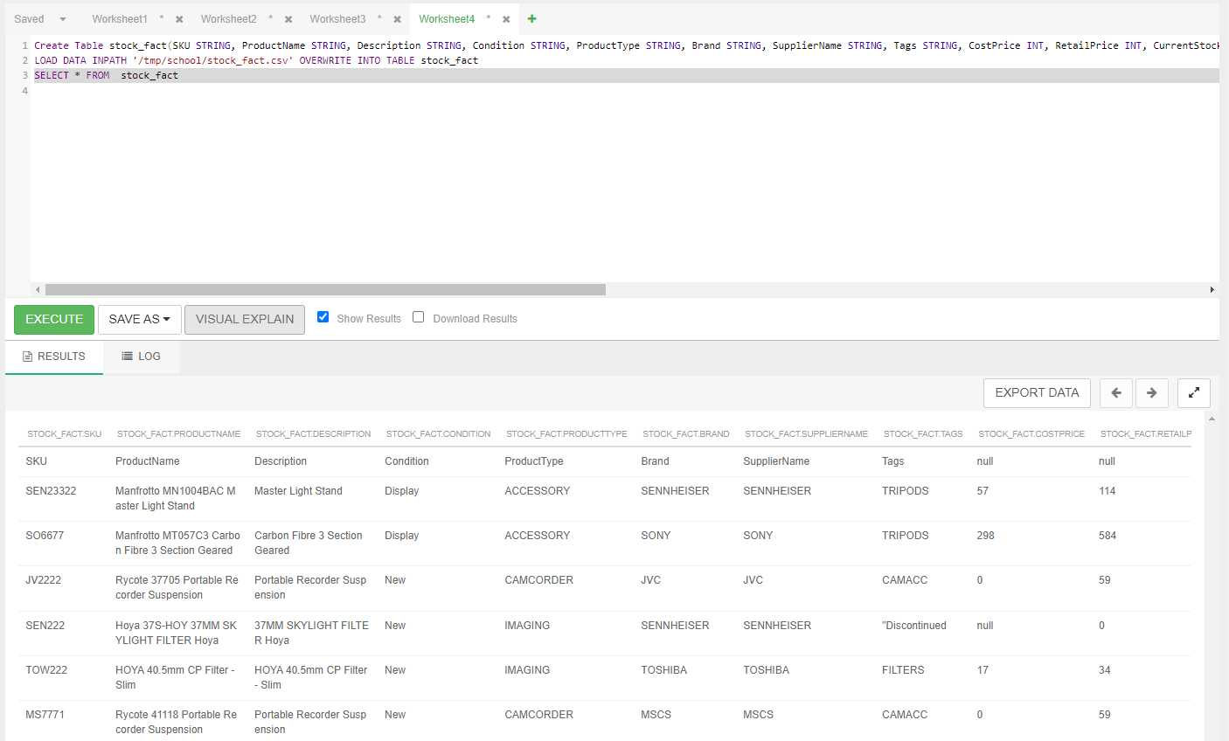

The above figure shows the code used to create stock fact table. here I used Ambari dashboard and loaded the data file which was used in azure data studio into hive to recreate fact table model. MsSql was used to create dimension and table in hive.

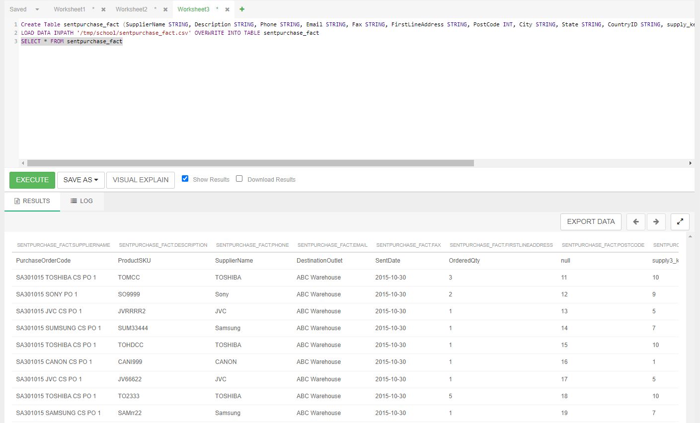

The above figure shows the code used to create sent purchase order fact table. here I used Ambari dashboard and loaded the data file which was used in azure data studio into hive to recreate fact table model. MsSql was used to create dimension and table in hive.

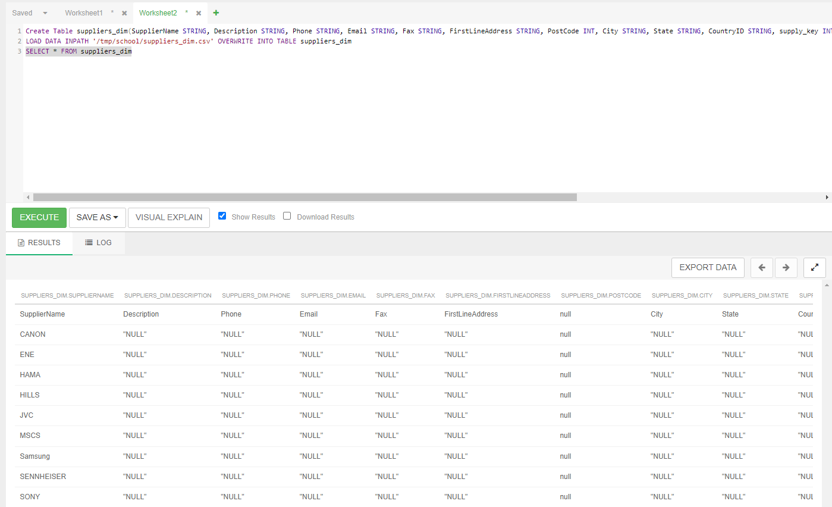

The above figure shows the code used to create supplier’s dimensional table. here I used Ambari dashboard and loaded the data file which was used in azure data studio into hive to recreate dimensional table model. MsSql was used to create dimension and table in hive.

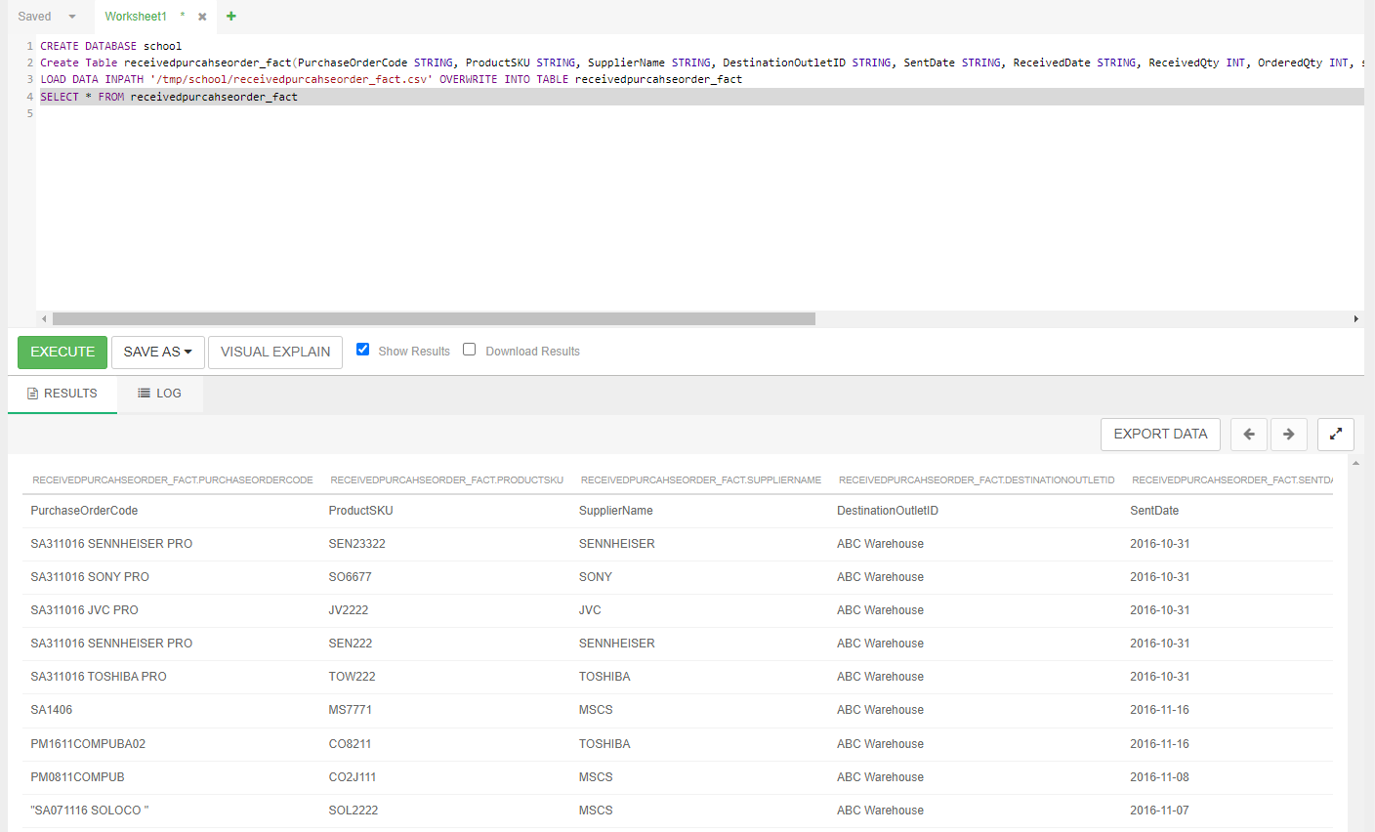

The above figure shows the code used to create received purchase order fact table. here I used Ambari dashboard and loaded the data file which was used in azure data studio into hive to recreate fact table model. MsSql was used to create dimension and table in hive.

**3.5** Demonstrate the use of Apache Pig for manipulating the loaded data.

**4. Written Report**

* 1. An introduction section that summarises the objectives of the course work and business case scenario.

The business case scenario given in this assignment is of a consumer retail company called ABC CONSUMER ELECTRONICS outlet which is a huge electronics retail company which has multiple stores in London and performs online business in the UK and Europe with over 200 brands and 10 categories. Electronic retail business is a competitive industry which makes it hard for companies like ABC electronics to keep up and currently they are having issues in their decision-making activities as they lack to produce reports and are having difficulty in performing analysis. The company is need of a business analyst to solve its problems where their business analyst team has created business document which serves as a guide to help the company. Inventory management being the most important case were controlling and reducing overstocks and understocks are the main activities which needs to be worked on.

Objectives of coursework:

One of the main objectives of the coursework is inventory management which is broken down into 3 steps where purchase orders sent is managed well by checking ordered quantity, sent date, product and supplier detail for every purchase order sent. 2nd step is storing the received purchased orders appropriately and 3rd is maintaining and controlling stocks. Coursework was divided into two parts, in part A we had to design and analyse dimensional data model where we had to create dimensional tables, fact tables, identify grain level to create central fact table and create graphical visualization of a star schema which links dimensional tables to their fact tables. In part b we must create a relational database in SSMS in Microsoft or azure data studio in case of mac where we had to create and store dimensional tables, fact tables, primary and foreign keys. Then we had to migrate the data into Horton works sandbox for further analysis we used hive and pig.

4.2 Analysis and design of dimensional data model.

Design and analysis of dimensional model were done through the raw data provided in txt and csv files. We had to extract the raw data’s and identify and create them into dimensional tables and central fact tables where three central fact tables were needed for this coursework. In part a as a group, we came up with 4-dimension tables called supplier, date, order, and product. The fact tables were stock, received purchase order and sent purchase order. Primary keys were made in each dimensional table which were identified as foreign keys in fact tables. In part b, I made a little change in the dimensional table where I removed received and sent dimension table and made supplier, date, and product dimension table as we are allowed to modify some changes in our schema when doing our individual work for part B. the fact tables remained the same.

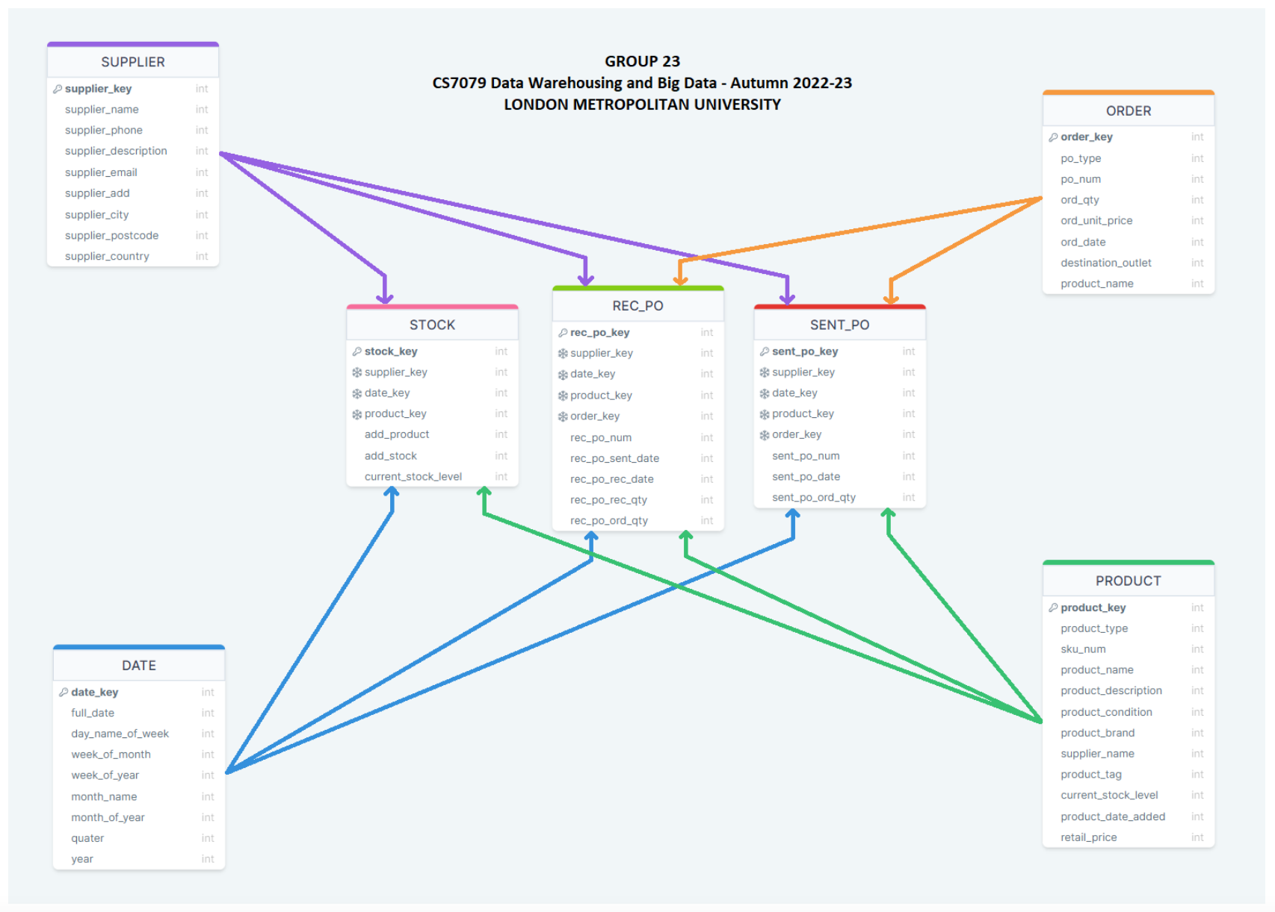

The above figure is the previous schema used for part A.

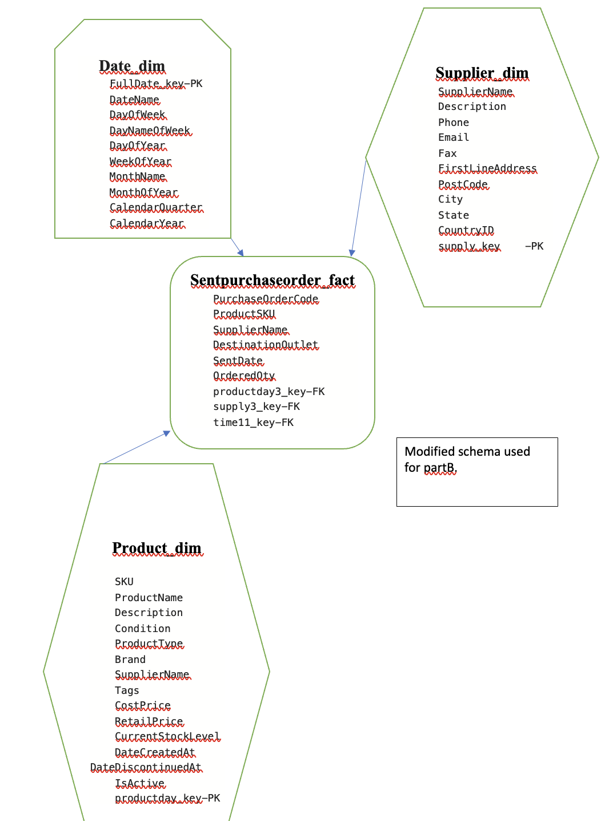New schema used for part B. sent purchase order fact schema linked with product, supplier, and date dimensions.

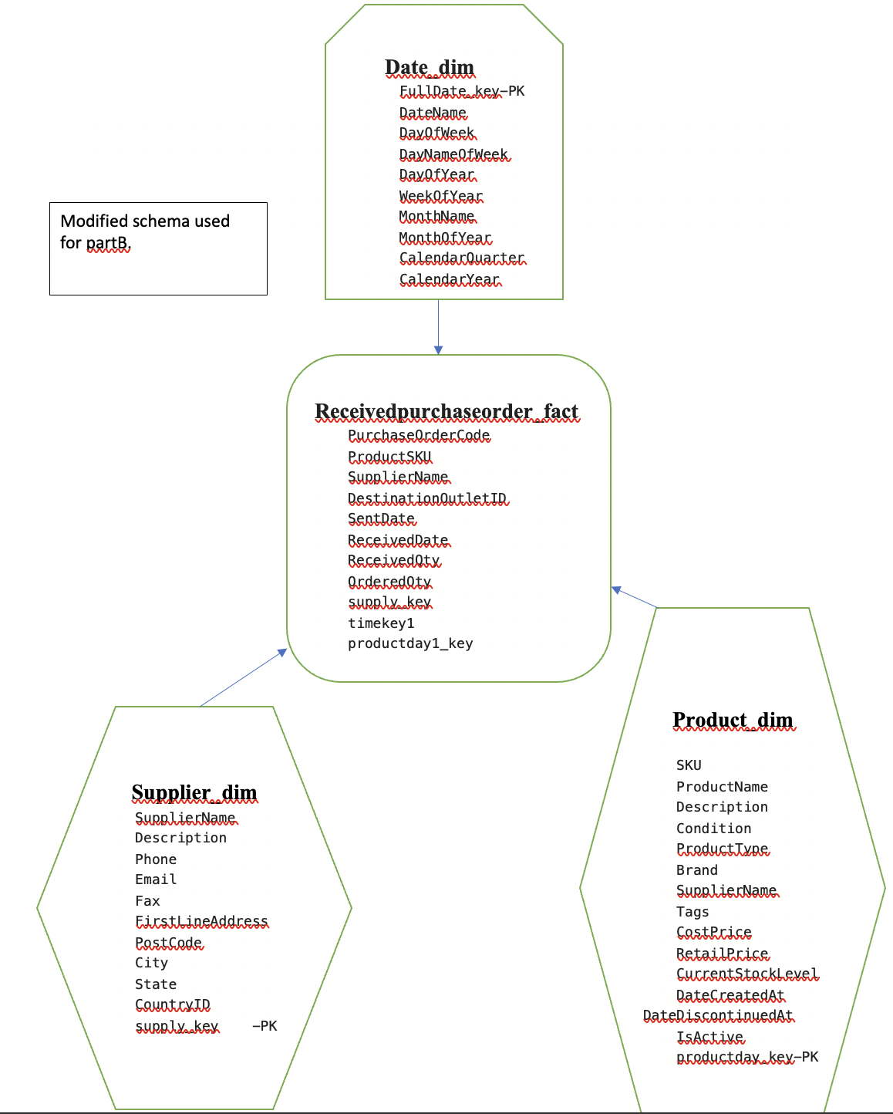

New schema used for part B. received purchase order fact schema linked with product, supplier, and date dimensions.

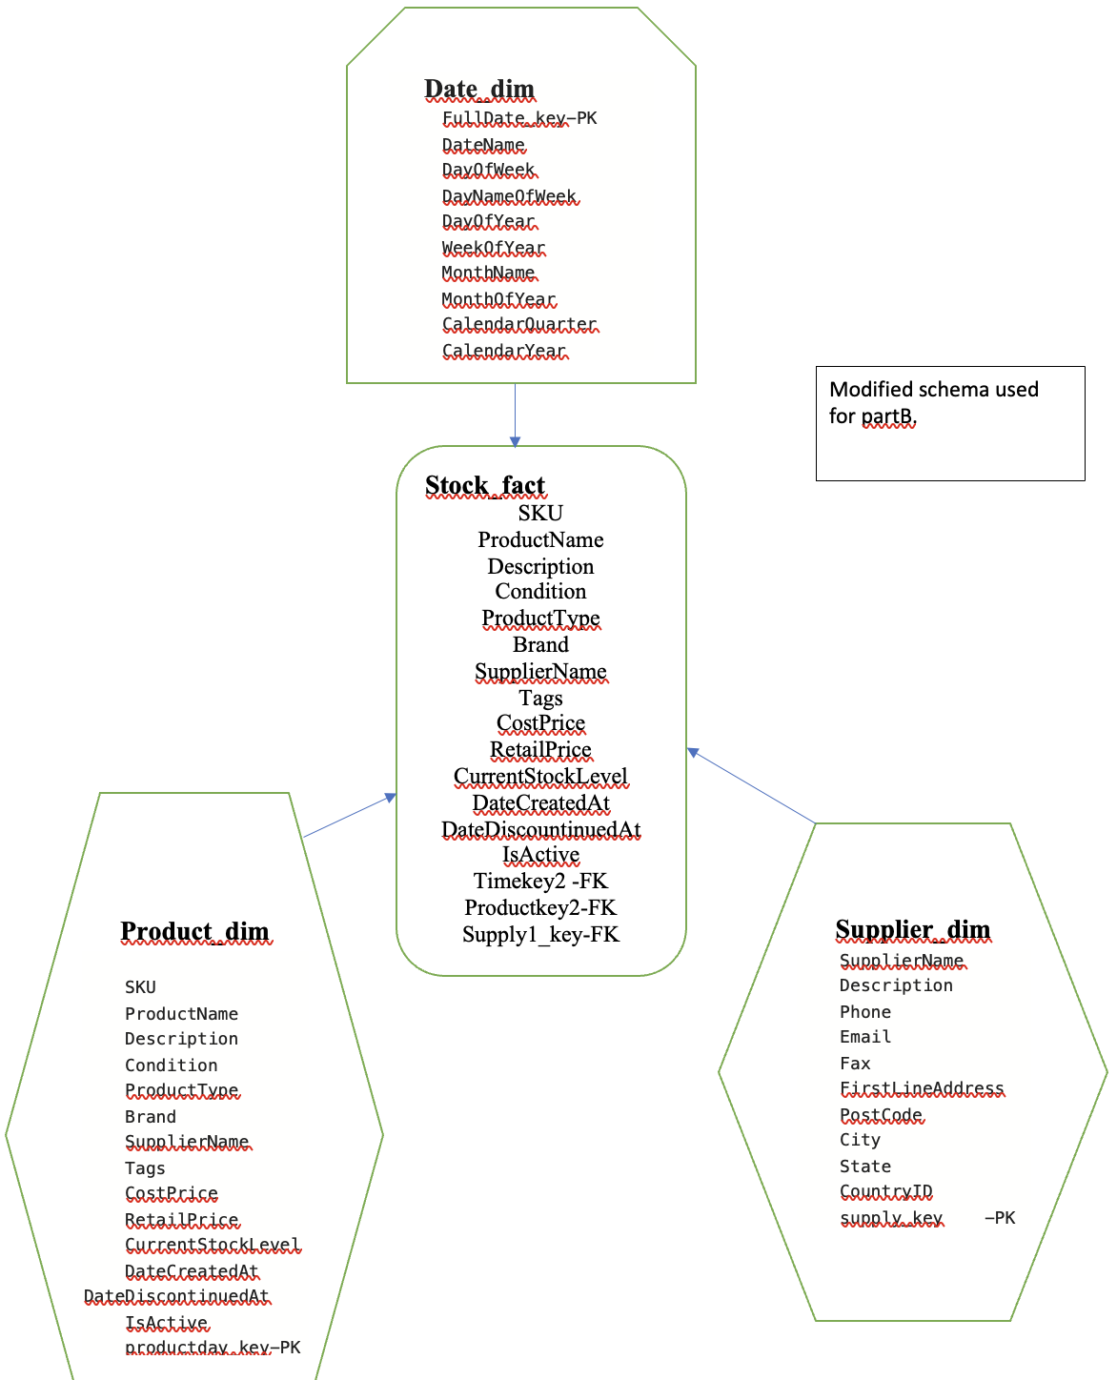

New schema used for part B. stock fact schema linked with product, supplier, and date dimensions.

4.3 Implementation and testing of data warehouse.

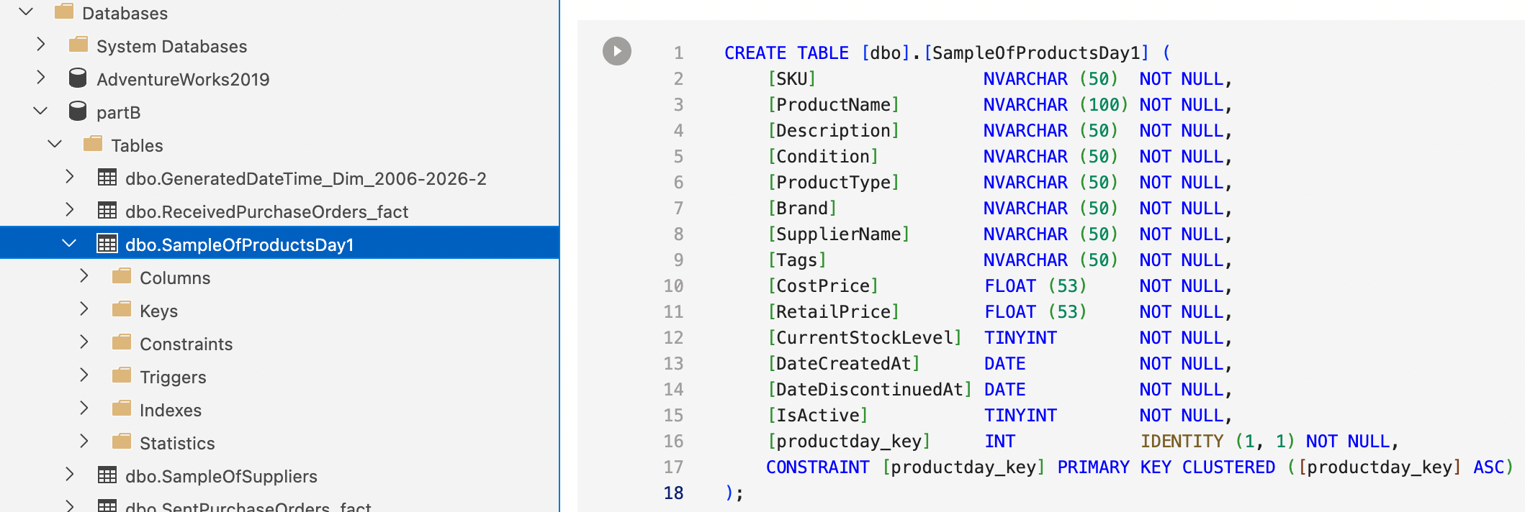

The figure above shows implementation and testing of creating table in data warehouse named azure data studio.



The figure above shows implementation and testing of creating table in data warehouse named Apache hive.

4.4 Implementation and testing of bigdata storage on HDFS.

4.5 Conclusion.

In this coursework I had to learn SQL from scratch as I had no previous knowledge, and it has now become one of my favourite languages. As a mac user I struggled with getting an alternate version of SSMS as it isn’t available in mac but found a software called azure data studio in which I have learned many commands and have now become familiar with it interface and can use it with ease. I have learned to use Ambari dashboard which has multiple analytics software like hive, data analytics tool, etc. which was very useful. I learnt about the fundamentals of schemas, different types of schemas like star, snowflake etc., I learnt how to identify and define grain, learned about dimensional tables, fact tables, primary keys, foreign keys, surrogate keys, natural keys. Overall, this course was very useful and sparked an interest to code and learn more often. Although I struggled as I had an mac laptop and everything in this coursework was Microsoft related, after completing this coursework it made me realize coding in mac is more fun.